**🚀 LangChain — The Power Tool for Modern LLM Applications**

**💡 What is LangChain?**

LangChain isn’t just a library — it’s a *framework* to build real-world LLM-powered apps. Think of it as a *conductor* for your language model orchestra.

Instead of just calling a model to "generate some text", LangChain helps you:

* **Chain multiple LLM calls together** (like question → summarization → final answer).
* **Integrate external tools** (e.g., Google Search, Python code execution).
* **Use memory to handle conversations** like a human would.
* **Create data-aware, agent-based apps** that interact with APIs, databases, and more.

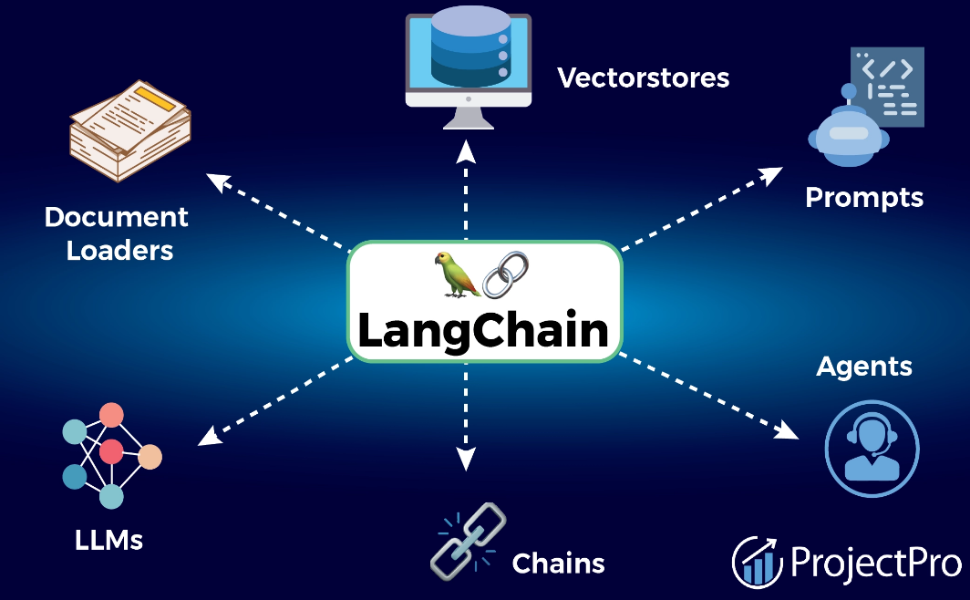

**🧠 Why Do We Even Need LangChain?**

Calling an LLM like GPT-4 directly is powerful, but limited. Here's what LangChain unlocks:

| **🔧 Without LangChain** | **⚙️ With LangChain** |
| --- | --- |
| One-off prompt → response | Full pipelines and logic |
| No state/memory | Conversational memory support |
| Hardcoded flows | Dynamic agents that make decisions |
| Manual tool integration | Plug-in tools like search/calculator easily |
| Limited reusability | Modular building blocks for reuse |

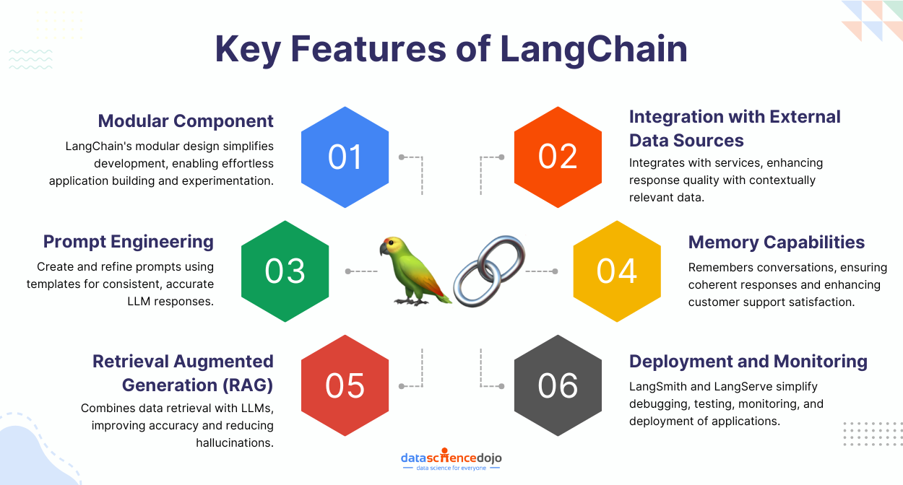

**🏭 Industrial Use Cases (What Companies Actually Do)**

LangChain is **industry-grade** and powers use cases like:

* ✅ **Chatbots with memory** (think HR bots, travel advisors)
* 📄 **Summarization/search from internal docs** (e.g., PDFs, emails)
* 🔍 **RAG Pipelines** (Retrieval-Augmented Generation)
* 🧑‍💻 **Agents that take actions** (e.g., query a database, call an API)
* 🧾 **Structured outputs** (JSONs for invoice extractors, auto form-fillers)

**Real Companies using LangChain**: LlamaIndex, Zapier, OpenAI-integrated tools, & even startups in fintech, healthcare, and legal tech.

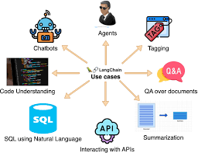

**⚙️ What LangChain Actually Does Under the Hood**

LangChain is built around core *components*:

1. **LLMs**: GPT-4, Claude, Falcon, Mistral, etc.
2. **Chains**: Logic chains that structure calls together.
3. **Memory**: Stores history for chat-like behavior.
4. **Tools**: Search engines, APIs, code interpreters.
5. **Agents**: Decision-making AI that chooses tools & actions.
6. **Document Loaders**: Read PDFs, Notion, Airtable, Google Docs, etc.
7. **Retrievers & Vector Stores**: Pinecone, FAISS, Chroma for smart document search.

**🌱 Future Scope (Why You Should Care Long-Term)**

* LangChain is pushing **LLM app dev from prompt hacking → real engineering**.
* Works with **open-source LLMs** (Mistral, LLaMA) + **closed APIs** (OpenAI, Anthropic).
* Perfectly fits into **enterprise AI pipelines** where LLMs need access to live data, decision making, or personalization.
* Great for building **custom copilots, business agents, AI integrations**, etc.
* LangChain is *modular* → you can replace pieces (LLM, memory, retriever) as tech evolves.

**✨ Suggested Topics You Can Add to GitHub**

Here are some extra ideas you can document:

1. 🔗 **LangChain vs LlamaIndex** – Which to use when?
2. 🧠 **What is RAG (Retrieval Augmented Generation)?**
3. ⚒️ **Best Vector Stores for AI Projects (Pinecone, FAISS, Chroma)**
4. 📚 **LangChain Tools You Should Know (Toolkits, Agents, Chains)**
5. 🔌 **LangChain + OpenAI API Practical Examples**
6. 🎯 **How to Build a Document Q&A App Using LangChain**
7. 🔥 **LangChain with Local LLMs (Mistral, LLaMA2, Falcon)**

**🔥 High-Value, Practical Topics**

**1. Agents in LangChain**

* What are Agents? (Tools that let LLMs reason and make decisions)
* Practical use: Tool-using bots, dynamic workflows
* Example: Use ReAct agent to query a search tool and return summarized answers
* Real-world use: Automating tasks, customer support bots, dynamic decision flows

**2. Memory in LangChain**

* Why use memory? → To maintain context across multiple messages
* Types: ConversationBufferMemory, ConversationSummaryMemory, etc.
* Use case: Chatbots that remember users or summarize previous interactions
* Practical: Build a bot that remembers previous customer support issues

**3. Retrieval-Augmented Generation (RAG)**

* What is RAG? → Enhancing LLMs with your own data (PDFs, docs, Notion, etc.)
* How it works: VectorDB + Embeddings + Retriever + LLM
* Tools: FAISS, ChromaDB, Pinecone
* Use case: Chat with your docs, private assistants
* Upload guide: How to use your own data (with chunking + embedding best practices)

**4. Function Calling (Tool Use by LLMs)**

* What is it? → Let LLMs trigger real functions (e.g., weather, calculator, APIs)
* Why it matters: LLM becomes interactive, not just a text responder
* Example: Build a smart travel planner that books tickets, fetches weather, etc.

**5. LangChain + APIs**

* Show how to integrate REST APIs inside LangChain flows
* Use case: Get live news, fetch stock prices, call GPT + external APIs

**6. LangChain + OpenAI Function Calling**

* Difference between LangChain agent calls vs. native OpenAI function calling
* When to use which

**7. LangChain for Automation**

* Use LangChain for automating repetitive workflows
* Real-world example: Resume screening + email drafting based on screening result

**8. Building an End-to-End Project with LangChain**

* Guide to build a full app:
  + Input → Query processing → Retrieval → LLM → UI
  + Add Streamlit or Gradio front-end
  + Logging with LangSmith

**9. LangChain vs LlamaIndex vs Haystack**

* Why LangChain?
* What are the differences?
* When to use what?

**10. LangSmith for Debugging and Tracing**

* How to debug, visualize and optimize LangChain workflows
* Add code samples with trace logs